Student worksheet

5.1 The Earth’s spheres are balanced

Pages 112–115

Layers of Earth

1 On the diagram below, label the following:

atmosphere, biosphere, crust, hydrosphere, inner core, lithosphere, mantle, outer core

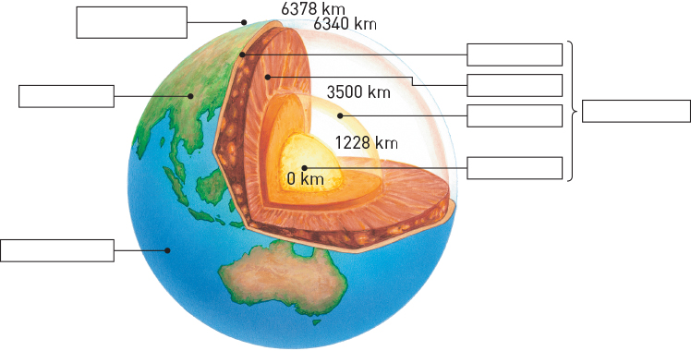

2 Fill in the following table based on your knowledge of the atmosphere, lithosphere, hydrosphere and biosphere.

|  |  |  |
| --- | --- | --- |
|  | What is it? | What is it made of? |
| Lithosphere |  |  |
| Atmosphere |  |  |
| Hydrosphere |  |  |
| Biosphere |  |  |

3 How does the atmosphere change as you travel further away from the Earth?

|  |
| --- |
|  |
|  |

4 In which layers of the atmosphere is the ozone layer located?

|  |
| --- |
|  |
|  |

5 In which layer of the atmosphere can an aurora be found?

|  |
| --- |
|  |

6 What is the cause of an aurora?

|  |
| --- |
|  |
|  |
|  |

Extend your understanding

Research two planets in our solar system and determine whether they have an atmosphere, lithosphere, hydrosphere and biosphere, and what each is made up of.

7 Planet 1:

|  |
| --- |
|  |

a Atmosphere

|  |
| --- |
|  |

b Lithosphere

|  |
| --- |
|  |

c Hydrosphere

|  |
| --- |
|  |

d Biosphere

|  |
| --- |
|  |

8 Planet 2:

|  |
| --- |
|  |

a Atmosphere

|  |
| --- |
|  |

b Lithosphere

|  |
| --- |
|  |

c Hydrosphere

|  |
| --- |
|  |

d Biosphere

|  |
| --- |
|  |